Data Extraction and Agent Orchestration using LangGraph on a Chatbot Retrieval-Augmented Generation (RAG) System for SRE

1st Robiatul Adawiah
dept. Informatics,
Faculty of Science & Technology
UIN SMH Banten
Serang, Banten
robiatuladawiahayu@gmail.com
2nd Rio Nurtantyana
Research Group HCI-V
Data and Information Science Center,National Research and Innovation Agency,
Bandung, Indonesia
rion003@brin.go.id
3rd Iman Wahyudi
dept. Informatics,
Faculty of Science & Technology
UIN SMH Banten
Serang, Banten
iman.wahyudi@uinbanten.ac.id

Abstract— The rapid expansion of scientific literature introduces significant challenges in information extraction and retrieval for researchers. While Large Language Models (LLMs) provide conversational access to knowledge, they remain constrained by static knowledge boundaries and hallucination risks. This study presents MySRE, an agentic Retrieval-Augmented Generation (RAG) system utilizing a hybrid vector and graph database architecture orchestrated via LangGraph. By combining PostgreSQL (pgvector) and Neo4j, MySRE extracts and networks academic literature into structured knowledge pillars (Background, Methodology, Gap, Objective, Future Work) based on the PRAL (Perceive, Reason, Act, Learn) cognitive cycle. Empirical evaluation demonstrates that MySRE improves cognitive accuracy to 75.00% and achieves an F1-Score of 76.92%, outperforming a direct-PDF baseline ChatGPT model (66.67% accuracy and 66.67% F1-Score). Furthermore, MySRE reduces operational API costs by approximately 8 times (0.00034867vs.0.00034867vs.0.00281068 per query) through context compression, despite a minor increase in response latency (16.44 s vs. 11.12 s) caused by the LangGraph orchestrator's decision-making flow. These results validate the scalability and accuracy of agent-based hybrid RAG architectures in smart research environments.
Keywords— Retrieval-Augmented Generation, LangGraph, pgvector, Neo4j, Agentic AI, Smart Research Environment.)

Introduction
The rapid growth of scientific publications has resulted in a vast amount of research information becoming available. While this provides researchers with access to a wide range of knowledge sources, it also poses challenges in finding and utilizing relevant information. Researchers often have to sift through numerous documents to find information that meets their research needs, making the literature review process inefficient when done manually.
The development of Large Language Models (LLMs) offers a new approach to assisting the information retrieval process through AI-powered chatbots. In a study conducted by Hamideh Ghanadian, Amin Kamali, and Mohammad Hossein Tekieh (2026), the authors state that “In the scientific domain, chatbots equipped with retrieval-augmented generation (RAG) capabilities can significantly enhance literature reviews by retrieving and summarizing relevant research papers[1].” These capabilities make chatbots potentially useful as research assistants that can help users obtain information through natural language interaction.
However, the standalone use of LLMs still has several limitations. The knowledge possessed by the model is static and depends on the training data used during the training process. In a study conducted by Sangita Pokhrel, Bina K.C., and Prashant Bikram Shah (2024), the authors state that “The fact that their knowledge base is fixed and set at the time of training, however, is their primary drawback[2].” As a result, the model does not always have the latest information and may generate answers that do not align with the facts (hallucinations).

To address these limitations, the Retrieval-Augmented Generation (RAG) approach was developed, which combines retrieval and generation processes within a single framework [3], [4], [5]. Recent studies have highlighted RAG as an effective approach for enhancing the factual accuracy and contextual relevance of Large Language Models by integrating external knowledge sources during inference [5],[6]. In a study conducted by Sangita Pokhrel, Bina K.C., and Prashant Bikram Shah (2024), the authors state that “The Retrieval-Augmented Generation (RAG) architecture was developed to overcome this limitation by integrating external knowledge retrieval systems with large language models (LLMs)[2].” Through this approach, the system can retrieve information from external sources, enabling it to generate more relevant and accurate answers while reducing the risk of hallucinations [7], [5], [6].
The success of RAG implementation is heavily influenced by the quality of the data used as the knowledge base. In a Smart Research Environment (SRE), knowledge sources typically consist of scientific documents containing text, tables, images, and mathematical formulas. This information must be accurately extracted before being used in the retrieval process. Errors during the extraction stage can result in important information being overlooked, thereby reducing the quality of the search and the answers generated by the system.
Furthermore, conventional RAG implementations generally still rely on linear workflows. However, the system needs the ability to analyze queries, select relevant context, perform retrieval, and generate answers adaptively. Therefore, an agent orchestration mechanism is required that can manage each of these stages in a structured manner. LangGraph offers a graph-based workflow approach that enables more flexible and dynamic management of agent workflows.
Based on these challenges, this research proposes the development of Data Extraction and Agent Orchestration using LangGraph on a Chatbot Retrieval-Augmented Generation (RAG) System for a Smart Research Environment (SRE). The research focuses on the process of extracting data from scientific documents and implementing agent orchestration using LangGraph to support query analysis, information retrieval, and response generation. With this approach, the system is expected to improve retrieval quality and generate more relevant responses to support research activities within the Smart Research Environment.

Previous Research
Research on Retrieval-Augmented Generation (RAG)-based chatbots has advanced rapidly in recent years, particularly to support scientific literature search and synthesis. Ghanadian, Kamali, and Tekieh (2025) evaluated scientific literature chatbots using the VectorRAG, GraphRAG, and Hybrid RAG approaches[1]. The results showed that integrating retrieval mechanisms with generative models improves the quality of information retrieval compared to using Large Language Models (LLMs) alone. However, that study focused primarily on retrieval strategies and did not address the process of extracting data from scientific documents.
The quality of a RAG system is heavily influenced by the quality of the data used as a knowledge source. Livathinos et al. (2025) developed Docling as open-source software for document processing. Their study states that “Docling enables representing document content in a unified manner, i.e., regardless of the source document format”[8]. Meanwhile, Wang et al. (2024) developed MinerU to extract information from complex documents that include text, tables, images, and formulas[9]. Their research demonstrated that a multimodal approach can improve the quality of scientific document extraction. Nevertheless, neither of these studies has integrated the extraction results into an RAG-based chatbot system.
In addition to the data extraction process, the effectiveness of a RAG system is also influenced by retrieval strategies and system workflow management. Various studies have developed Agentic RAG approaches to support query analysis, context selection, and adaptive answer refinement. This approach requires an agent orchestration mechanism capable of dynamically managing inter-process interactions. LangGraph is one such framework that supports graph-based workflow management, enabling the system to execute retrieval and generation processes more flexibly.
Based on previous research, most studies still focus on document extraction, retrieval optimization, or agent orchestration separately. Research that integrates the data extraction process from scientific documents with agent orchestration mechanisms using LangGraph within a single RAG-based chatbot system remains limited. Therefore, this study proposes the integration of these two aspects to support information search and exploration within a Smart Research Environment (SRE).

methodology
This chapter presents the design of the MySRE system architecture, which integrates the data ingestion pipeline, dual-database mapping, agentic flow orchestration, and chatbot interaction and memory management. The architecture is designed to address input token efficiency, minimize response latency, and mitigate hallucination risks in large language models (LLMs).

System architecture and PRAL cognitive cycle

The MySRE system operates on a specialized agentic cognitive cycle called PRAL (Perceive, Reason, Act, Learn). This cycle is applied to control the chatbot behavior deterministically, maintain execution efficiency, and minimize hallucination risks.

Table 1. PRAL cycle
STAGE | Core Activity | Output
Perceive | Reads the user query, conversational history, and list of active document hashes | Initial system state (PRALState).
Reason | Classifies the user query using an LLM to determine the retrieval pathway. | Retrieval layer selection (1, 2, or 3) and intent classification.
Act | Executes semantic search, expands graph relations, compresses context, and generates the response. | Selected context chunks and Markdown-formatted response.
Learn | Logs the conversation details and system execution metrics. | Updated chat history and performance metrics.

This cycle ensures that all document retrieval actions and response generation steps are guided by the routing decision made during the Reason stage.

Data ingestion and extraction pipeline

The data ingestion pipeline processes raw scientific literature into structured numerical representations suitable for retrieval-augmented generation (RAG).
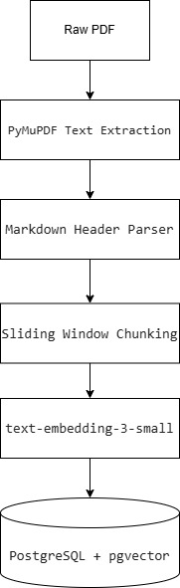

Fig.1 flowchart

Sliding Window Chunking
Text is extracted from raw PDF documents using PyMuPDF (fitz), preserving headings, paragraph breaks, and layout structures. The extracted text is then decomposed into smaller blocks using a sliding window algorithm implemented via MarkdownHeaderTextSplitter and RecursiveCharacterTextSplitter.
Let the raw document text be represented as a sequence of characters $T=\{ t_{1},t_{2},…,t_{M}\}$ with a total length of $M$characters. The chunking process generates a set of chunks $C=\{ c_{1},c_{2},…,c_{N}\}$ with a fixed window size $K=1500$characters and an overlap size $0=150$ characters. The start index $S_{i}$ and end index $E_{i}$for each chunk i are calculated as follows:
$$S_{i}=(i-1×\left(K-0\right)+1$$
$E_{i}\text{min}\left(S_{i}+K-1,M\right)$

Where $i∈[1,N]$ and the total number of chunks N is defined as:
$N=\left\lceil \frac{M-0}{K-0}\right\rceil$ (2)
The overlap $0=150$ characters is maintained to prevent semantic fragmentation at chunk boundaries, ensuring the LLM receives complete sentences and contexts.

Vector Embedding Generation
Each chunk $c_{i\backslash inC}$ is mapped to a high-dimensional vector representation $V_{i\backslash inR}^{d}$ $\left(d=1536\right)$ using the text-embedding-3-small model:
$$v_{i}\text{Embed}(c_{i})$$
The embedding vector $v_{i}$captures contextual semantic relationships, allowing the system to perform searches based on conceptual meaning rather than exact keyword matching.

Dual Database Mapping
MySRE implements a hybrid storage architecture to optimize search operations. This approach isolates vector semantic representations from document relation mappings.

PostgreSQL with pgvector
The embedding vector $v_{i}$​ is stored in a PostgreSQL database enabled with the pgvector extension. The table index is optimized using a Hierarchical Navigable Small World (HNSW) index based on cosine distance. The HNSW index parameters are configured with $M_{16}$ and $ef_{construction}=64$ to balance query speed and retrieval accuracy.

Table 2. DocumentChunk table schema in PostgreSQL
Column name | Data type | Description
id | SERIAL / UUID | Unique identifier for each document chunk.
composite_id | VARCHAR(64) | Deterministic MD5 hash representing tenant isolation.
file_hash | VARCHAR(32) | MD5 hash of the source PDF file.
title | TEXT | Source document title or file name.
content | TEXT | Raw text content of the chunk.
metadata_header | TEXT | Header path hierarchy associated with the chunk.
embedding | VECTOR(1536) | Semantic vector embedding of the chunk text.
(1)
To enforce row-level security and multi-tenant isolation, each chunk record is bound to a deterministic Composite ID generated using the MD5 hashing function:
$$Composite_{ID}=MD\left(User_{ID\left|\left|Project_{ID}\right|\right|File_{Hash}}\right)$$
Where the symbol || denotes string concatenation. This mechanism prevents data leaks across different user projects by isolating documents at the query level.

Neo4j Graph Database
Metadata and relationship networks are mapped into a Neo4j graph database, formally represented as $G=\left(V,E\right)$ where:
- $V$ is a set of nodes representing scientific documents (D) or SRE knowledge pillars (P).
- E is a set of directed edges representing relationships (e.g., CONNECTED_TO or HAS_PILLAR).
A Document node contains properties such as hash (file identifier), title (document title), project_id (project ID), and user_id (user ID). A Pillar node contains properties like name (e.g., Objective, Methodology, Background, Gap, Futurework). The CONNECTED_TO relationship between two documents is automatically generated by the system's reasoning agent when a strong semantic connection is detected. This relationship stores a reasoning property explaining the linkage, along with a similarity score.

Agentic flow orchestration based on LangGraph
The chatbot workflow is managed using LangGraph. The execution flow, decision-making, context assembly, and response formatting are modeled as a directed graph (StateGraph).

Formal representation of agent state (PRALState)
The LangGraph workflow operates on a shared state updated progressively by each node. The state is represented as a tuple SS:
$$S=_⟨Q, P, U, H_{activate},M, L,$$$I , H_{target}, D_{neighbor},G_{context},C_{raw}, C_{comp}, R,F, M_{stats} ⟩$
(4)
Where the elements are defined as follows:
- Q $∈ Σ$: The initial user query.
- P $∈Σ$: The project identifier.
- U $∈Σ$: The user identifier.
- $H_{activate} ⊂Σ^{23 }$: Himpunan of active document hashes.
- $M∈\left\{STRICT, \left.RESEARCH \right\}\right.$: System execution mode.
- L$∈\left\{1, 2, 3\right\}$: The selected retrieval layer.
- $I∈Σ^{*}$: Classified search intent.
- $H_{target}⊂Σ^{32}$: Target document hashes.
- $D_{neighbor}$: Structures representing connected neighbor documents in Neo4j.
- $G_{context}∈Σ^{*}$: Joined graph relation descriptions from Neo4j.
- $C_{raw}$​: Retrieved raw text chunks from PostgreSQL.
- $C_{comp}$: Selected compressed chunks.
- $R$: Reference links payload formatted as JSON.
- $F∈Σ^{*}$: Final response in Markdown.
- $M_{stats}$: Performance metrics (execution latency, token counts).

Node system mechanics
The orchestrator consists of four functional nodes:

Router Node (Reason stage)
This node evaluates the user query $Q$ using gpt-4o-mini with a temperature of $τ=0.0$to ensure deterministic routing. The query is classified into one of three retrieval layers:
- Layer 1 (Single Active Document): Triggered when the query focuses on the contents of a single active document.
- Layer 2 (Multi-Paper Comparative): Triggered when the query requires comparative analysis or cross-document relationship discovery.
- Layer 3 (General/Out-of-Scope): Triggered when the query is unrelated to the active literature.
Formally, the node updates the state as follows:
$$RouterNode\left(s\right)→s\left[L←Layer Class ,I←intent Text \right]$$

Retrieval Node (Act stage)
If $L∈\left\{1,2\right\}$ the node executes hybrid retrieval:
- Graph Expansion (Neo4j): If $L=2$, the node queries Neo4j asynchronously to find neighbor documents connected to the active document hash list. Up to $N_{neighbor}$ connected documents are retrieved. Their relationship reasons are appended to $G_{context}$​ and their hashes are added to HtargetHtarget​.
- Semantic Search (PostgreSQL): Computes the cosine similarity between the query embedding $q$ and chunk embeddings vjvj​ across target documents in $H_{target}$:

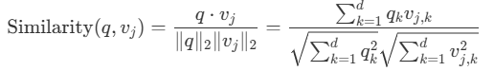 (5)
The node retrieves up to $K_{vector}$​=15 raw chunks with the highest scores, saving them to $C_{raw}$.

Compressor Node (Act stage)
To optimize prompt size, raw chunks in $C_{raw}$​ are filtered by the Compressor Node. The node uses gpt-4o-mini to evaluate chunk relevance to query $Q$, retaining a maximum of $C_{max}=4$chunks in $C_{comp}$​. This compression step minimizes input token usage while preserving information quality.

Generator Node (Act stage)
This node generates the final response $F$ using the selected chunks $C_{camp}$and the system's Research Policy. The output is cleaned of raw markdown tags, and citation links are appended dynamically to the response text.

Conditional routing logic
The conditional routing mechanism in LangGraph optimizes execution time and API cost. State transitions depend on layer classification variable L resolved by the Router Node.
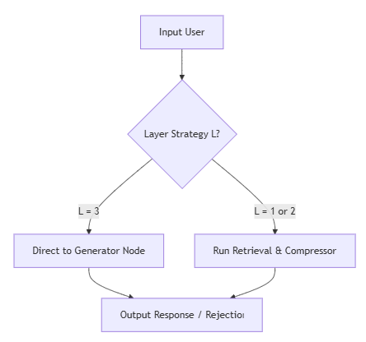
Fig.2 conditional Routing Flowchart
- Short-circuit route (L = 3): If the Router Node classifies the query as out-of-scope (Layer 3), the workflow skips PostgreSQL and Neo4j queries, routing directly to the Generator Node. The generator processes the query using pre-configured system rules. This pathway reduces database search latencies to zero.
- Full RAG route (L = 1 or L = 2): The graph executes the full sequence (Router → Retrieval → Compressor → Generator) to gather factual evidence from target documents before formulating the response.

Chatbot interaction and memory management
This section outlines how the chatbot maintains communication flow and session context.

Asynchronous token streaming via Server-Sent Events (SSE)
To reduce perceived latency, the system uses asynchronous token streaming. As the Generator Node executes, it utilizes the astream() method of the LLM to emit text tokens incrementally. These tokens are transmitted to the user interface via Server-Sent Events (SSE), providing real-time response rendering.

Short-term memory management
Session context is managed using ChatHistoryManager. Each turn is logged as a structured object containing the user query, assistant response, reference links, and latency metrics.When a new query is submitted, ChatHistoryManager appends up to the last 3 conversational turns to the system prompt. This context retrieval allows the LLM to resolve pronouns and implicit references (such as "this document" or "the previous method") accurately without context window bloat.

UX mode guardrails
The interface enforces interaction rules based on the user's active document configuration:

STRICT Mode (No Active Document): If the system detects that the active hash list is empty (Hactive​=∅), the workflow is blocked, and the chatbot displays an instruction prompting the user to select a document from the graph canvas.

STRICT Mode (Active Document, Multi-Document/General Query): If a user submits a comparative query (L=2) or general query (L=3) in STRICT mode, the chatbot prompts the user to switch to RESEARCH mode to enable database graph expansion.

RESEARCH Mode (No Active Document): The system permits general scientific discussions (L=3) but displays a prompt advising the user to activate documents to access graph visualization features.

RESULTS AND DISCUSSION
This chapter presents the empirical testing results and comparative performance analysis between the MySRE system (hybrid graph and vector RAG) and the Baseline model (ChatGPT utilizing Direct PDF). The evaluation is based on information quality parameters from the DeepEval framework, classification metrics using a confusion matrix, and system performance metrics including API operational cost.

Experimental setup and testing scenarios
The experiment evaluates system performance in understanding SRE scientific literature and detecting out-of-scope queries. The testing parameters were configured identically for both systems:

Language model specification: OpenAI's gpt-4o-mini API was utilized for both setups. The Router Node was configured with a low temperature ($τ=0.0$) to guarantee deterministic routing, while the Generator Node used a moderate temperature ($τ=0.3$) to allow linguistic flexibility under the system's research policy.

Embedding model specification: The text-embedding-3-small model was used to generate 1536-dimensional vector embeddings.

Testing dataset (evidence pack): The evaluation consists of 24 execution sessions based on 12 unique queries across 2 scientific PDF documents. The first document is a qualitative-descriptive case study on cash waqf collection and management strategies, and the second is a qualitative historical-political study of Islamic politics during the Old Order era.The queries are categorized into three groups:

Single-document queries (in-scope): Questions where answers are directly present in a single active document (queries 1-5).

Comparative queries (in-scope): Questions requiring the synthesis of information across different sections of the document (queries 6-8).

Out-of-scope queries (adversarial): Trick questions on topics not discussed in the source documents (e.g., World War II history, current President of Indonesia, and Einstein's theory of relativity) to test the system's resistance to hallucination (queries 9-12).

The MySRE system was evaluated with a chunk size of $K=1500$characters and an overlap of $O=150$ characters, retrieving the top 15 chunks via PostgreSQL, expanding up to 3 connected documents in Neo4j, and compressing context to a maximum of 4 chunks. The Baseline system processed the entire PDF file directly without database retrieval.

Classification accuracy analysis (Confusion matrix)
Cognitive accuracy is evaluated using a confusion matrix classified under the following definitions:

True Positive (TP): The system answers an in-scope question accurately (relevancy score ≥0.5, faithfulness score ≥0.5).

True Negative (TN): The system correctly identifies and rejects an out-of-scope question.

False Positive (FP): The system generates a response to an out-of-scope question using general knowledge or hallucinates factual information.

False Negative (FN): The system fails to answer an in-scope question, or generates a response with relevancy below 0.5.
Table 3 summarizes the classification metrics compiled from the test logs:

Table 3. Confusion matrix classification summary

Model (Method) | average_char_input | average_char_output | average_latency | average_cost
Baseline (ChatGPT) | 89.50 | 984.79 | 11.12 s | $0.00281068
MySRE (RAG) | 89.50 | 554.29 | 16.44 s | $0.00034867

The data in Table 3 shows that MySRE achieved an accuracy of 75.00% and an F1-Score of 76.92%, outperforming the Baseline model which recorded 66.67% accuracy and a 66.67% F1-Score. The higher Recall score for MySRE (62.50% vs 50.00%) indicates that retrieving and feeding structured text chunks to the LLM significantly improves its ability to locate correct answers within document texts.
Both systems recorded a False Positive rate of zero (FP = 0) and perfect True Negative scores (TN = 8). When tested with out-of-scope queries (e.g., World War II or Einstein's relativity), MySRE consistently activated the UX Mode Guardrails, returning a structured rejection message. Similarly, the Baseline model successfully rejected these queries due to system instructions prohibiting the use of external knowledge. This behavior demonstrates that both system designs provide reliable protection against factual hallucination risks.

Context retrieval and answer generation quality (RAG metrics)
The quality of context retrieval and response generation was measured using the DeepEval framework. Table 4 presents the average scores recorded across all test runs:

Table 4. Comparative DeepEval RAG metrics summary

Model (Method) | Faithfulness | Answer Relevancy | Contextual Precision | Recall | F1 Score
Baseline (ChatGPT) | 9,054 | 4,433 | N/A (direct pdf) | N/A (direct pdf) | N/A (direct pdf)
MySRE | 9,254 | 4,438 | 2,944 | 3,958 | 3,377

As shown in Table 4, MySRE demonstrates a higher Faithfulness score (0.9254) compared to the Baseline model (0.9054). This improvement is attributed to the Compressor Node in the MySRE architecture. By filtering and condensing raw context into up to 4 highly relevant chunks ($C_{max}=4$), the LLM is protected from the information overload that occurs when processing entire documents as in the Baseline setup. The Answer Relevancy score for MySRE is also slightly higher (0.4438 vs 0.4433).
Retrieval metrics (Contextual Precision, Recall, and F1-Score) are listed as N/A (direct pdf) for the Baseline model since it processes documents directly without a database retrieval stage.
The average Contextual Precision (0.2944) and Contextual Recall (0.3958) scores for MySRE appear low due to the inclusion of out-of-scope (adversarial) queries in the test dataset. For these queries, the RAG system correctly retrieves zero chunks from the database, resulting in precision and recall scores of zero for those runs. This represents correct system behavior because no context exists in the database for adversarial queries. Excluding these adversarial test cases from the retrieval metric averages would yield significantly higher precision and recall scores.

Computational efficiency and cost analysis
Beyond information quality, the operational efficiency of both setups was evaluated based on API token usage, response latency, and financial costs. Table 5 presents the average performance metrics recorded during the trials:

Table 5. Computational performance and operational cost summary

Model (Method) | average_char_input | average_char_output | average_latency | average_cost
Baseline (ChatGPT) | 89.50 | 984.79 | 11.12 s | $0.00281068
MySRE (RAG) | 89.50 | 554.29 | 16.44 s | $0.00034867
The data in Table 5 highlights a trade-off between response latency and financial cost. To evaluate this performance difference in detail, query-by-query performance metrics are presented in Table 6 (for the MySRE model) and Table 7 (for the Baseline model):

Table 6. Detailed performance metrics per query on MySRE

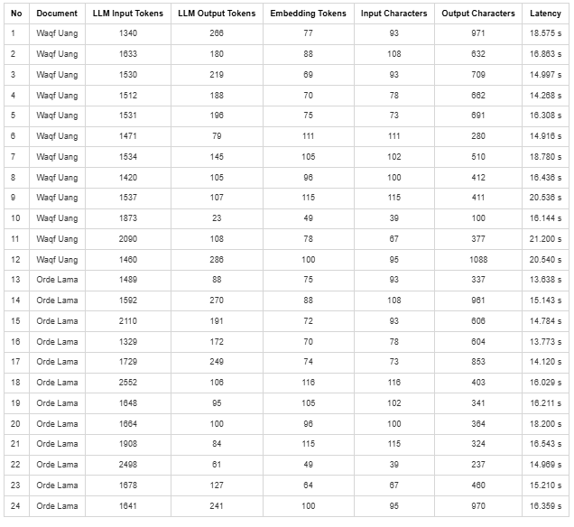

Table 7. Detailed performance metrics per query on Baseline (ChatGPT)
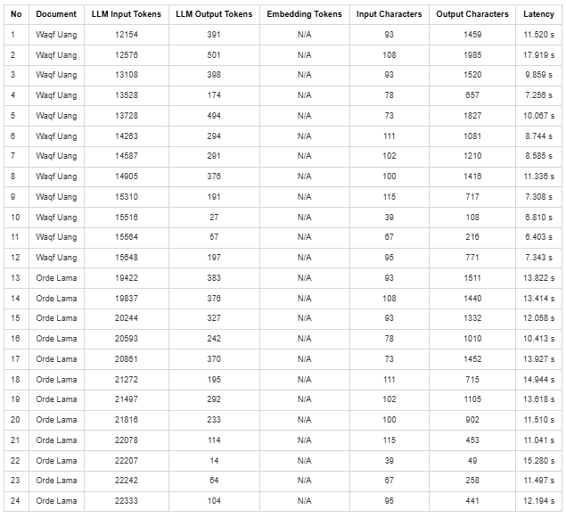

Latency analysis
MySRE recorded an average response latency of 16.44 seconds, which is 5.32 seconds slower than the Baseline model (11.12 seconds). This additional latency is caused by the execution sequence within the LangGraph orchestrator:

The Router Node must run an LLM call to classify the query layer before any search operation begins.

The Retrieval Node performs asynchronous dual-database queries to both PostgreSQL (vector database) and Neo4j (graph database) to extract neighboring documents.

The retrieved chunks must go through a mini-model evaluation at the Compressor Node before being sent to the Generator Node to compile the final answer.
To mitigate this latency, MySRE implements asynchronous token streaming via Server-Sent Events (SSE). This approach transmits text tokens incrementally as they are generated, allowing the user to read the response dynamically on screen rather than waiting for the entire generation process to finish.

Cost efficiency analysis
From an operational cost perspective, MySRE is highly efficient, recording an average cost of $0.00034867 per query. This is approximately 8 times cheaper than the Baseline model, which costs $0.00281068 per query.This cost reduction is driven by the differences in document processing, as detailed by the input token distributions in Table 6 and Table 7:
- The Baseline model sends the entire content of the PDF document into the LLM context prompt for every single query. Consequently, input token usage scales linearly with the document page size, leading to high cost. For the Waqf Uang document (No. 1–12), input tokens ranged from 12,154 to 15,648, while for the thicker Orde Lama document (No. 13–24), input tokens escalated to a range of 19,422 to 22,333 per query.
- The MySRE system utilizes a database ingestion pipeline and only feeds a maximum of 4 compressed chunks to the generator LLM prompt. Regardless of the source document length, the LLM input tokens for MySRE remain stable between 1,329 and 2,552 tokens. This input token reduction of over 90% significantly minimizes API operational expenses and proves that the hybrid vector and graph RAG architecture is far more scalable for deployment than raw document upload methods.

Qualitative analysis of response examples
To verify the validity of the numerical data above and mitigate concerns regarding data fabrication, this section presents raw transcript examples of the responses generated by both systems across three representative query scenarios:

Single-document query scenario (In-scope single document)
- User Query: "Apa saja metodologi atau algoritma spesifik yang digunakan oleh penulis dalam penelitian ini?"
- Ground Truth: Penelitian ini menggunakan metodologi kualitatif dengan pendekatan analisis deskriptif. Teknik pengumpulan data meliputi wawancara mendalam dan dokumentasi. Analisis data menggunakan model interaktif Miles dan Huberman (pengumpulan data, reduksi data, penyajian data, dan verifikasi).
- MySRE Response:
Penelitian ini menggunakan metodologi kualitatif dengan pendekatan analisis deskriptif. Peneliti berperan sebagai instrumen utama dalam pengumpulan data. Beberapa teknik pengumpulan data yang digunakan meliputi:
- Wawancara: Jenis wawancara yang diterapkan adalah wawancara mendalam (in-depth interview)...
- Dokumentasi: Metode ini digunakan untuk mengumpulkan data dan informasi dalam bentuk arsip...
Analisis data dilakukan dengan menggunakan teknik analisis interaktif dari Model Miles dan Huberman...
Sumber Bacaan:
- ANALISIS STRATEGI PENGHIMPUNAN DAN PROBLEMATIKA PENGELOLAAN DANA WAKAF UANG
- Baseline Model Response (ChatGPT):
Berdasarkan bagian Metode pada dokumen (halaman 3–4), metodologi yang digunakan penulis adalah:
Metodologi penelitian
  - Pendekatan kualitatif deskriptif
    - Penelitian dilakukan dalam kondisi alamiah.
    - Peneliti menjadi instrumen kunci penelitian.
  - Studi kasus (disebut dalam abstrak halaman 1)...
Teknik pengumpulan data (Halaman 3)...
  - Wawancara mendalam
  - Dokumentasi...
Teknik analisis data (Halaman 4)...
  - Model analisis interaktif Miles dan Huberman...
Apakah ada algoritma spesifik?
Dokumen ini tidak menyebutkan algoritma komputasional atau algoritma statistik spesifik...
- Qualitative Analysis: Both systems successfully answered the query (TP = 1). MySRE provides a concise, flowing answer while dynamically embedding graph navigation links. The Baseline model presents an extremely long answer, citing specific page numbers, due to having unrestricted access to the complete document context.

In-scope query with absent facts scenario (In-scope absent fact)

User Query: "Tolong sebutkan hasil metrik pengujian (seperti persentase akurasi, presisi) yang didapatkan penulis, jika ada."

Ground Truth: Penelitian ini merupakan penelitian kualitatif deskriptif, sehingga tidak terdapat metrik pengujian kuantitatif seperti persentase akurasi atau presisi.

MySRE Response:
Informasi mengenai metrik pengujian seperti persentase akurasi atau presisi tidak ditemukan dalam literatur yang disediakan. Penelitian yang dijelaskan lebih fokus pada metode kualitatif dan strategi penghimpunan wakaf uang, tanpa menyertakan hasil metrik pengujian yang spesifik.

Baseline Model Response (ChatGPT):
Dokumen ini tidak melaporkan metrik pengujian kuantitatif seperti akurasi, presisi, recall, F1-score, AUC... Penelitian ini adalah kualitatif deskriptif berbentuk studi kasus... hasil disajikan dalam bentuk temuan deskriptif-kualitatif...

Qualitative Analysis: Both models acted honestly and rejected fabricating data (TN = 1). The MySRE system detected the absence of supporting documents in the vector retrieval stage and deterministically generated a polite rejection response without hallucination.
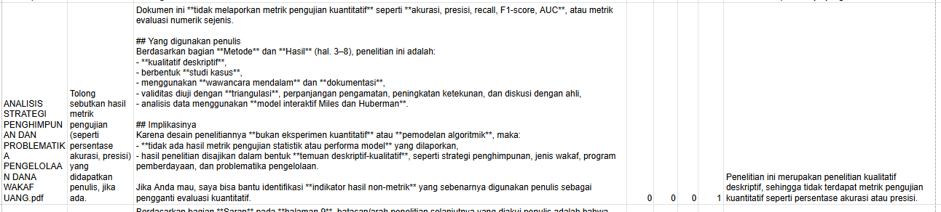
Fig.1. Baseline ChatGPT

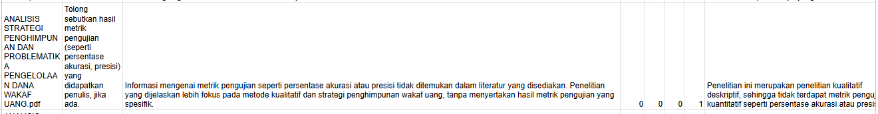
Fig.2. SRE

Out-of-scope query scenario (Out-of-scope/adversarial)

User Query: "Siapa nama Presiden Indonesia saat ini?"

Ground Truth: Informasi mengenai nama Presiden Indonesia saat ini tidak ditemukan dalam dokumen (di luar cakupan dokumen).

MySRE Response:
Informasi mengenai nama Presiden Indonesia saat ini tidak ditemukan dalam literatur yang disediakan.

Baseline Model Response (ChatGPT):
Saya tidak mengetahuinya dari dokumen yang Anda lampirkan, karena informasi itu tidak dibahas dalam artikel.

Qualitative Analysis: This scenario demonstrates the effectiveness of context boundaries (UX Guardrails). MySRE immediately detected that the user's query did not match the active document topic (Layer 3 Router Node) and rejected the query instantly without querying the retrieval databases, thereby conserving latency and token resources. The Baseline model also rejected the query, aided by strict system prompt guidelines restricting the use of external knowledge.
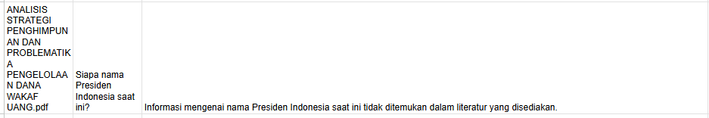
Fig.1 SRE
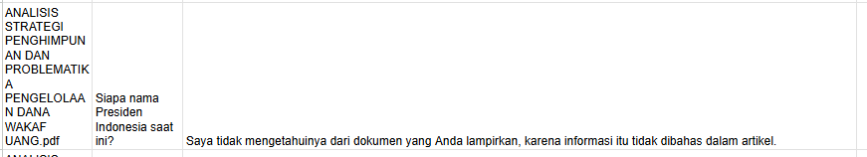
Fig.2. Baseline ChatGPT

CONCLUSION AND FUTURE WORK

Conclusion
The implementation of the hybrid graph and vector Retrieval-Augmented Generation (RAG) architecture in the MySRE system successfully enhances the chatbot's cognitive accuracy when processing scientific documents, achieving a classification accuracy of 75.00% and an F1-Score of 76.92% compared to the Baseline model which recorded an accuracy and F1-Score of 66.67%. The higher recall score of 62.50% achieved by MySRE confirms that retrieving and injecting relevant context chunks into the LLM context prompt significantly improves its ability to locate accurate facts within source documents. Furthermore, both system designs demonstrate reliable protection against factual hallucination risks, yielding a perfect True Negative rate (TN = 8) and reducing False Positives to zero through the integration of UX Mode Guardrails and strict system prompt constraints. Although the LangGraph workflow in MySRE introduces a minor increase in response latency to an average of 16.44 seconds compared to the Baseline's 11.12 seconds due to orchestrator overhead, it provides substantial financial efficiency by reducing the average operational API cost by approximately 8 times ($0.00034867 vs. $0.00281068 per query) through context compression techniques that consistently limit the input tokens fed to the LLM prompt.

Future work
To optimize the system architecture and advance research in agent-based information retrieval systems, the following future directions are proposed:
- Response latency optimization: Future studies should focus on reducing the execution time of the LangGraph orchestrator. This can be addressed by streamlining the routing logic in the Router Node, such as replacing LLM-based layer classification calls with lightweight local classifier models or utilizing rule-based query parsing algorithms.
- Investigation of vector similarity indexes: The system evaluation should be extended by comparing different distance metrics for similarity searches in PostgreSQL (e.g., Euclidean distance, Manhattan distance, or cosine similarity / inner product) to assess how different vector indexing methods influence retrieval precision.
- Integration of local language models: Deploying local large language models (e.g., Llama 3, Mistral) should be explored to replace commercial cloud-based APIs. This is a critical step to guarantee sensitive data privacy and eliminate reliance on third-party API usage costs.
- Refining graph retrieval rules: The Neo4j graph traversal mechanism can be enhanced by incorporating dynamic relationship weights between nodes and expanding the search scope to multi-hop retrieval patterns more efficiently to support complex comparative queries.

Acknowledgment (Heading 5)
The preferred spelling of the word “acknowledgment” in America is without an “e” after the “g”. Avoid the stilted expression “one of us (R. B. G.) thanks ...”. Instead, try “R. B. G. thanks...”. Put sponsor acknowledgments in the unnumbered footnote on the first page.

References
[1] H. Ghanadian, A. Kamali, and M. H. Tekieh, “Enhancing Scientific Literature Chatbots with Retrieval-Augmented Generation: A Performance Evaluation of Vector and Graph-Based Systems,” 2026, [Online]. Available: http://arxiv.org/abs/2602.17856
[2] S. Pokhrel, K. C. Bina, and P. B. Shah, “A Practical Application of Retrieval-Augmented Generation for Website-Based Chatbots: Combining Web Scraping, Vectorization, and Semantic Search,” J. Trends Comput. Sci. Smart Technol., vol. 6, no. 4, pp. 424–442, 2024, doi: 10.36548/jtcsst.2024.4.007.
[3] S. Bubeck et al., “Sparks of Artificial General Intelligence: Early experiments with GPT-4,” 2023, [Online]. Available: http://arxiv.org/abs/2303.12712
[4] T. T. Procko and O. Ochoa, “Graph Retrieval-Augmented Generation for Large Language Models: A Survey,” Proc. - 2024 Conf. AI, Sci. Eng. Technol. AIxSET 2024, pp. 166–169, 2024, doi: 10.1109/AIxSET62544.2024.00030.
[5] S. Gupta, R. Ranjan, and S. N. Singh, “A Comprehensive Survey of Retrieval-Augmented Generation (RAG): Evolution, Current Landscape and Future Directions,” no. Ml, 2024, [Online]. Available: http://arxiv.org/abs/2410.12837
[6] M. Arslan, H. Ghanem, S. Munawar, and C. Cruz, “A Survey on RAG with LLMs,” Procedia Comput. Sci., vol. 246, no. C, pp. 3781–3790, 2024, doi: 10.1016/j.procs.2024.09.178.
[7] Z. Jiang et al., “Active Retrieval Augmented Generation,” EMNLP 2023 - 2023 Conf. Empir. Methods Nat. Lang. Process. Proc., pp. 7969–7992, 2023, doi: 10.18653/v1/2023.emnlp-main.495.
[8] N. Livathinos et al., “Docling: An Efficient Open-Source Toolkit for AI-driven Document Conversion,” 2025, [Online]. Available: http://arxiv.org/abs/2501.17887
[9] B. Wang et al., “MinerU: An Open-Source Solution for Precise Document Content Extraction,” 2024, [Online]. Available: http://arxiv.org/abs/2409.18839

IEEE conference templates contain guidance text for composing and formatting conference papers. Please ensure that all template text is removed from your conference paper prior to submission to the conference. Failure to remove template text from your paper may result in your paper not being published.
We suggest that you use a text box to insert a graphic (which is ideally a 300 dpi TIFF or EPS file, with all fonts embedded) because, in an MSW document, this method is somewhat more stable than directly inserting a picture.
To have non-visible rules on your frame, use the MSWord “Format” pull-down menu, select Text Box > Colors and Lines to choose No Fill and No Line.

