Preparation of Papers for JUTI (Jurnal Ilmiah Teknologi Informasi)

First A. Akmal Haikal Hamzah ^{1,*)}, Second B. Abdurakhman prasetyadi S.Sos., M.P. ²⁾, and Third C. Tabrani, M.T.I
³⁾
^{1, 2)} Department Informatics and institution UIN Sultan Maulana Hasanudin Banten
R593+8V7, Sukajaya, Kec. Curug, Kota Serang, Banten 42171

akmalhaikalhamzah@gmail.com¹⁾ahmad.tabrani@uinbanten.ac.id
²⁾, and abdu059@brin.go.id
³⁾

ABSTRACT

Flooding remains one of Indonesia's most critical environmental challenges, particularly in urban areas traversed by major river basins such as the Ciliwung watershed. The increasing frequency and intensity of flood events are driven by rapid urbanization, land-use changes, population growth, and climate variability. Conventional flood monitoring systems typically provide static information and often lack the integrated visualization capabilities needed to support real-time decision-making. Recent advancements in Digital Twin technology offer new opportunities to represent the physical environment through dynamic virtual models linked to real-time data sources.

This research aims to design and develop a Digital Twin dashboard for the Ciliwung watershed that integrates real-time flood monitoring features with flood predictions based on historical data. The dashboard was developed using a user-centered design approach and implemented as a web-based platform. The system combines geospatial visualization, environmental monitoring indicators, flood risk mapping, and predictive analytics to provide a comprehensive situational overview. The proposed dashboard enables stakeholders to monitor water levels, rainfall intensity, flood-prone areas, and historical flood trends through an interactive interface.

The research results demonstrate that the dashboard effectively visualizes environmental conditions within the watershed and improves accessibility to flood-related information. Furthermore, the integration of historical flood prediction capabilities supports disaster preparedness and early warning strategies. Applying the Digital Twin concept to watershed management contributes to the creation of a smarter environmental monitoring system and enhances decision-making processes for flood mitigation.

Keywords: Digital Twin, Flood Monitoring, Flood Prediction, Smart Environment, Watershed Management

Introduction
Geographically, Indonesia is situated in a tropical region characterized by high annual rainfall intensity. Consequently, flooding is one of the most frequent natural disasters affecting various parts of the country. Disaster management reports indicate that floods account for a significant percentage of total annual natural disasters, often resulting in substantial economic losses, infrastructure damage, and disruptions to community activities. One of the most vulnerable river systems in Indonesia is the Ciliwung River Basin, which flows through the Bogor, Depok, and Jakarta areas.

The Ciliwung River plays a vital role in supporting urban and environmental systems. However, rising population density and urban development have significantly altered the basin's natural hydrological characteristics. The conversion of green open spaces into residential and commercial areas has reduced water infiltration capacity and increased surface runoff. As a result, even moderate rainfall can cause river water levels to rise and heighten the risk of flooding in downstream areas.

Flood monitoring has traditionally relied on manual observation and fragmented information systems. Although various agencies provide rainfall and water level data, this information is often disjointed, making it difficult for the public and policymakers to interpret quickly. In emergency situations, the lack of integrated visualization can hinder response times and reduce the effectiveness of mitigation efforts.

The emergence of Digital Twin technology offers a promising solution to these challenges. A Digital Twin is a virtual representation of a physical object, system, or environment that continuously receives and processes real-world data. By integrating sensor data, environmental datasets, and analytical models, Digital Twins provide capabilities for real-time monitoring, simulation, and prediction. Originally developed for manufacturing and industrial applications, Digital Twin technology has now expanded into diverse fields such as smart cities, transportation systems, healthcare, and environmental management.

In watershed management, a Digital Twin can create a dynamic representation of river conditions by combining hydrological data, Geographic Information Systems (GIS), and predictive analytics. Such a system enables users to monitor environmental conditions in real-time while predicting various potential future scenarios. This capability is crucial for flood risk management, where early detection and prediction can significantly mitigate the impact of disasters.

This research focuses on designing a Digital Twin dashboard for the Ciliwung watershed that integrates real-time flood monitoring features with flood prediction based on historical data. The dashboard is designed as an interactive platform to visualize environmental conditions, support disaster preparedness, and facilitate data-driven decision-making. The proposed design employs modern web technologies and user interface principles to ensure the system's accessibility, usability, and scalability.

The objective of this study is:

Designing a Digital Twin dashboard for the Ciliwung watershed.
Integrating real-time environmental monitoring features into the dashboard.
Implementing flood prediction visualizations based on historical data.
Evaluating the effectiveness of dashboard-based environmental monitoring from a user interface perspective.

This research contributes by demonstrating the application of Digital Twin technology in watershed management through a practical and interactive dashboard prototype. It also highlights the role of visualization technology in raising public awareness and strengthening disaster response strategies.

Literature review

Digital Twin Technology
The Digital Twin concept was first introduced by Michael Grieves in the context of product lifecycle management. A Digital Twin is a digital replica of a physical system that continuously exchanges information with its real-world counterpart. The integration of physical and virtual environments enables monitoring, analysis, optimization, and prediction.
A Digital Twin system generally consists of three main components:

1. Physical entity
2. Virtual representation
3. Data connection layer
Physical entities represent real-world systems, while virtual representations provide digital models capable of simulating environmental behavior. The data connection layer ensures synchronization between the physical and digital environments.

Various recent studies indicate that Digital Twin technology can enhance operational efficiency, predictive maintenance, and decision-support systems. Its application in the environmental sector encompasses water resource management, smart city monitoring, climate resilience, and disaster risk reduction.

Pengelolaan Daerah Aliran Sungai
A watershed (or river basin) is a geographic area where rainfall collects and flows toward a common outlet, such as a river, lake, or reservoir. Effective watershed management requires continuous monitoring of hydrological variables, including rainfall, water levels, runoff, and land use.
The Ciliwung watershed covers an area of ​​approximately 347 square kilometers and serves millions of residents across various urban areas. Due to rapid urbanization, the watershed faces mounting challenges regarding flood control and environmental sustainability.
Real-Time Monitoring Systems
Real-time monitoring systems utilize sensors and communication technologies to continuously collect and transmit environmental data. Such systems enable stakeholders to monitor current conditions without significant delay.
Common parameters monitored in flood management systems include:

1. River water level
2. Rainfall intensity
3. Flow velocity
4. Water discharge

The integration of Internet of Things (IoT) technology has further enhanced the capabilities of real-time monitoring systems by enabling automated data acquisition and remote accessibility.

RESEARCH METHODOLOGY

Research Method
This study employs a Research and Development (R&D) approach focused on the design and prototyping of a Digital Twin Dashboard for the Ciliwung River Basin. The objective is to develop an interactive, web-based platform capable of visualizing environmental conditions in real-time while providing information on historical flood predictions.

The research process consists of five stages:

1. Literature Review
2. Requirements Analysis
3. UI/UX Design
4. Prototype Development
5. Evaluation and Analysis
The methodological framework is illustrated in Figure 1.

Figure 1. Research Framework
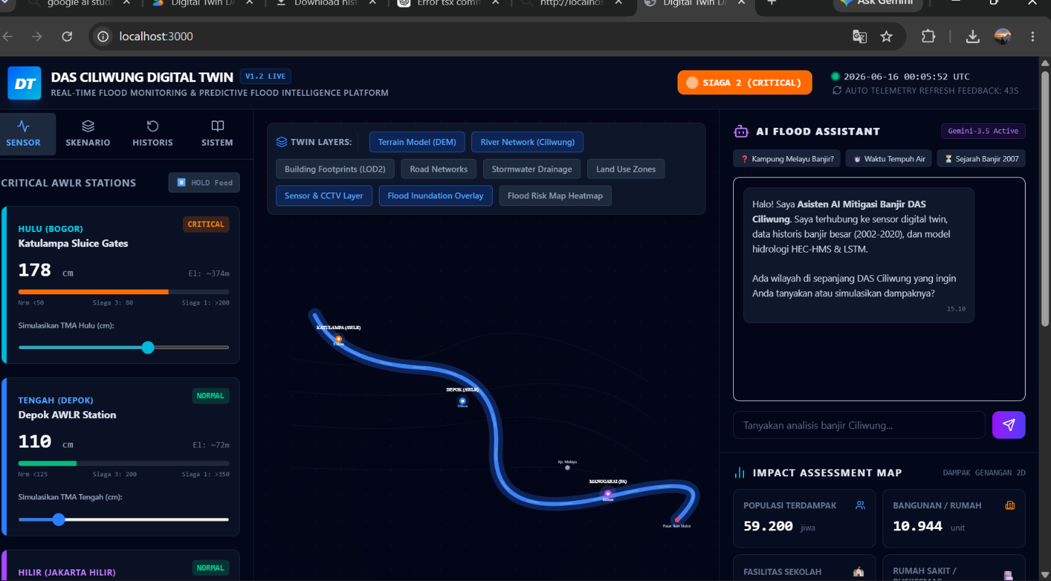

3.2 Requirement Analysis
The requirement analysis stage was conducted to identify system functionalities and user needs. The dashboard was designed for stakeholders such as:
- Government agencies
- Disaster management authorities
- Environmental researchers
- General public
The functional requirements of the proposed system are presented in Table I.
Table I. Functional Requirements
No | Requirement | Description
FR1 | Real-Time Monitoring | Display water level information
FR2 | Rainfall Monitoring | Visualize rainfall intensity
FR3 | Flood Risk Mapping | Display flood-prone areas
FR4 | Historical Prediction | Show flood prediction trends
FR5 | Data Analytics | Present statistical information
FR6 | Interactive Visualization | Enable map interaction
FR7 | Dashboard Accessibility | Accessible through web browsers
3.3 Arsitektur Sistem
The proposed Digital Twin architecture consists of three layers:
A. Data Acquisition Layer
The data acquisition layer collects information from various environmental sources, including:
1. Water level sensors
2. Rainfall sensors
3. Historical flood datasets
4. Meteorological information

B. Data Processing Layer
The processing layer handles:
1. Data cleaning
2. Data integration
3. Predictive analysis
4. Flood risk classification

C. Visualization Layer
The visualization layer presents information through a web dashboard comprising:
1. Interactive GIS maps
2. Monitoring cards
3. Prediction charts
4. Analytics panels
This architecture enables continuous synchronization between physical environmental conditions and their digital representations.

3.4 UI/UX Design Method
The dashboard interface was designed using User-Centered Design (UCD) principles. The process included:
1. User Analysis
2. Wireframe Design
3. High-Fidelity Prototype Development
4. User Experience Evaluation
The interface prioritizes:
• Simplicity
• Consistency
• Accessibility
• Responsiveness
The design is implemented using ReactJS and Tailwind CSS.
3.5 Tumpukan Teknologi
Table II presents the technologies used in the development process.
Table II. Technology Stack
Component | Technology
Frontend | ReactJS
Styling | Tailwind CSS
Build Tool | Vite
Mapping | Leaflet
Chart Visualization | Recharts
Deployment | Vercel
Version Control | GitHub

Tabel II menyajikan teknologi yang digunakan dalam proses pengembangan.

Tabel II. Tumpukan Teknologi
Komponen Teknologi
Frontend ReactJS
Penataan Gaya Tailwind CSS
Alat Build Vite
Pemetaan Leaflet
Visualisasi Grafik Recharts
Deployment Vercel
Kontrol Versi GitHub

RESULTS AND DISCUSSION
The developed Digital Twin dashboard provides an interactive environment for monitoring hydrological conditions in the Ciliwung River Basin.

The prototype has been successfully launched online and can be accessed via:
https://digital-twin-das-ciliwung.vercel.app
This dashboard integrates visualization techniques with the Digital Twin concept to represent the condition of the river basin in near real-time.

Main Dashboard Interface
The main dashboard serves as a centralized monitoring interface.
This interface displays:
1. Current water level
2. Rainfall conditions
3. Flood warnings
4. Environmental indicators
Users can quickly assess environmental conditions via visual status indicators.
Figure 2. Main Dashboard Interface
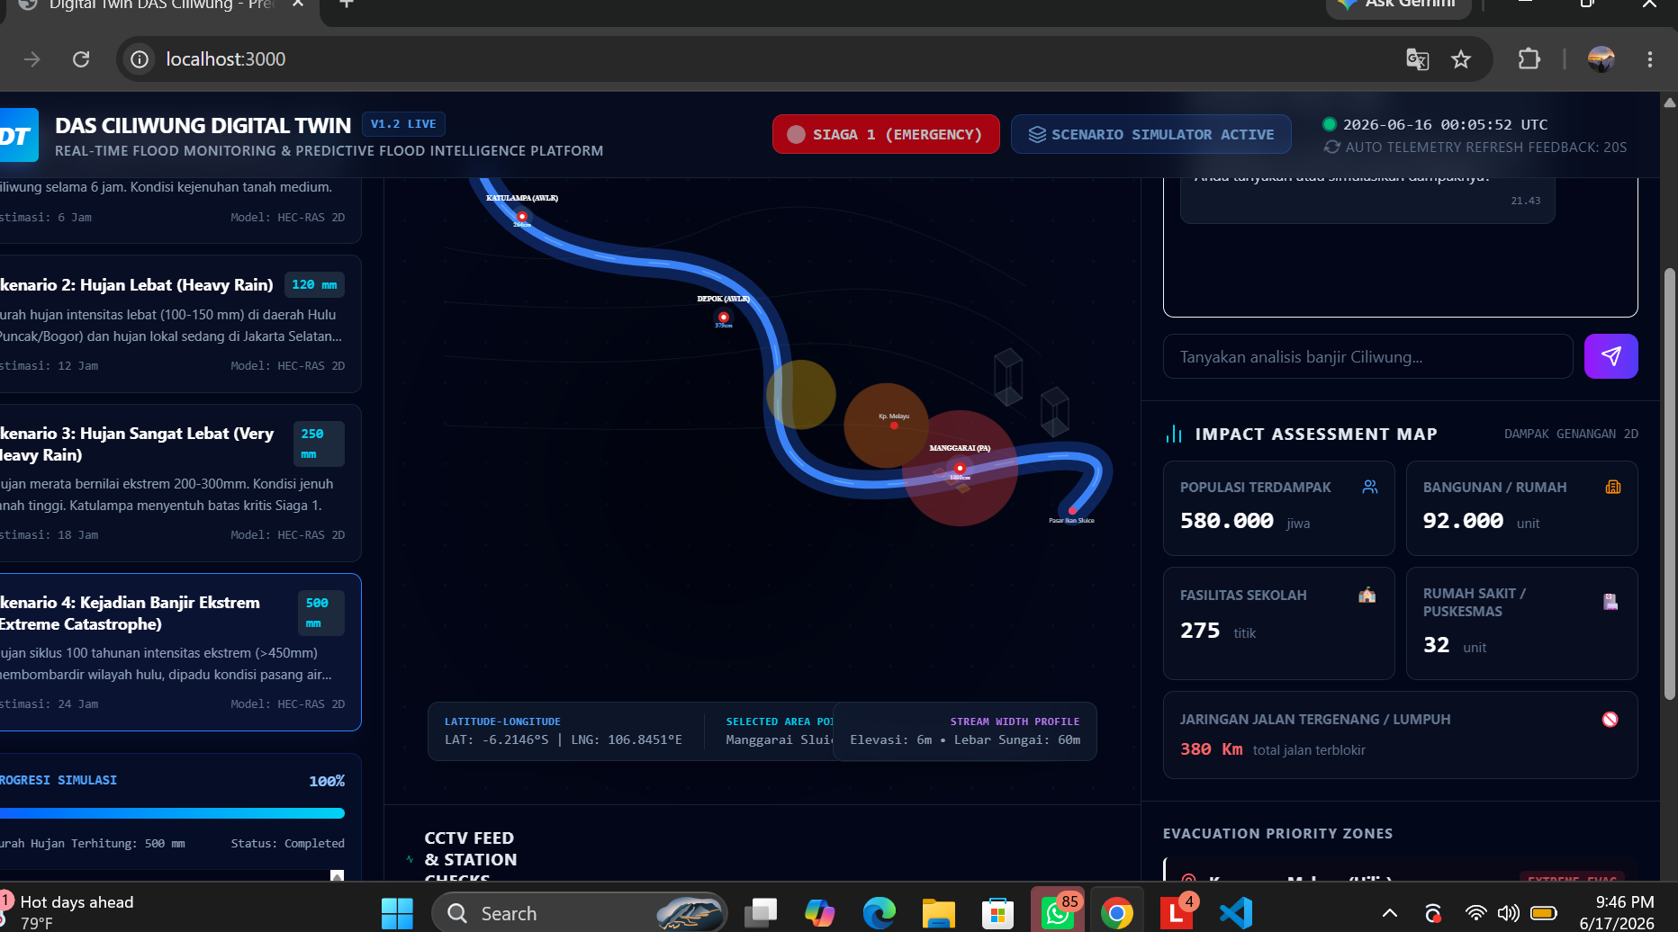

This design employs a card-based layout to enhance information readability and reduce cognitive load.

Interactive Watershed Visualization
One of the system's key features is an interactive watershed map.
This map allows users to:

1. Identify monitoring locations
2. View flood-prone zones
3. Observe watershed boundaries
4. Access environmental information
- Figure 3. Interactive Watershed Map

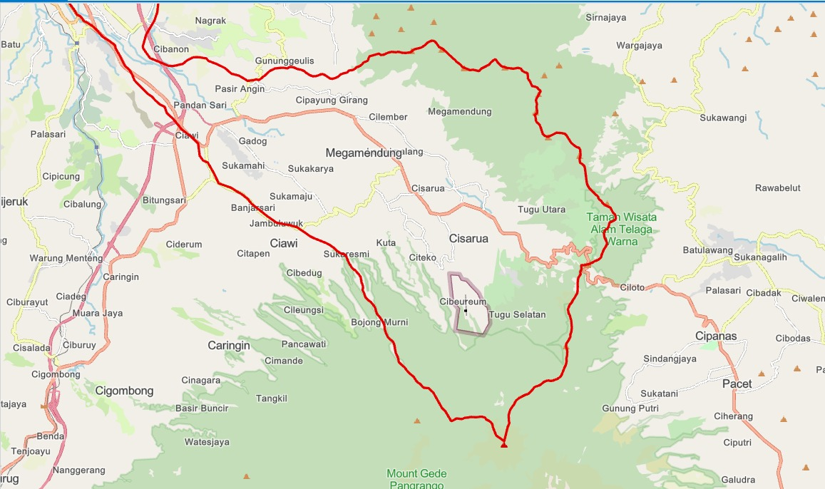

Geospatial visualization significantly enhances situational awareness during potential flood events.

Real-time monitoring is a key component of the Digital Twin concept.
• Dashboards display:
• Water level status
• Rainfall intensity
• Environmental conditions
• Warning indicators

Flood status is categorized into four levels:
Table III. Flood Alert Levels
Status Description
Safe Normal conditions
Alert Rising water levels
Watch Potential for flooding
Danger High risk of flooding

Figure 4. Real-time Monitoring Panel

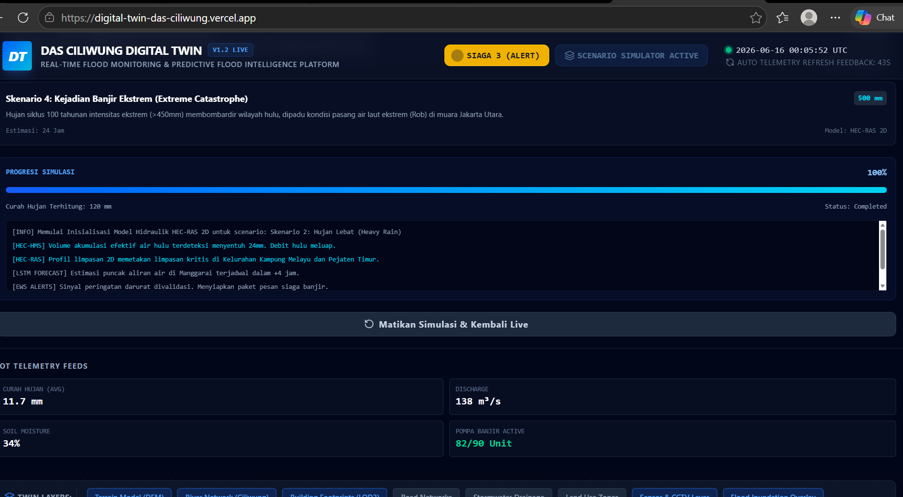

Visual indicators use color coding to facilitate decision-making.

Historical Flood Prediction

The historical flood prediction feature presents analytical information based on past flood records.

This prediction module analyzes:
Historical rainfall patterns
Water level trends
Past flood events

The analysis results are presented through graphical visualizations that help users identify future risks.

Figure 5. Historical Flood Prediction Dashboard

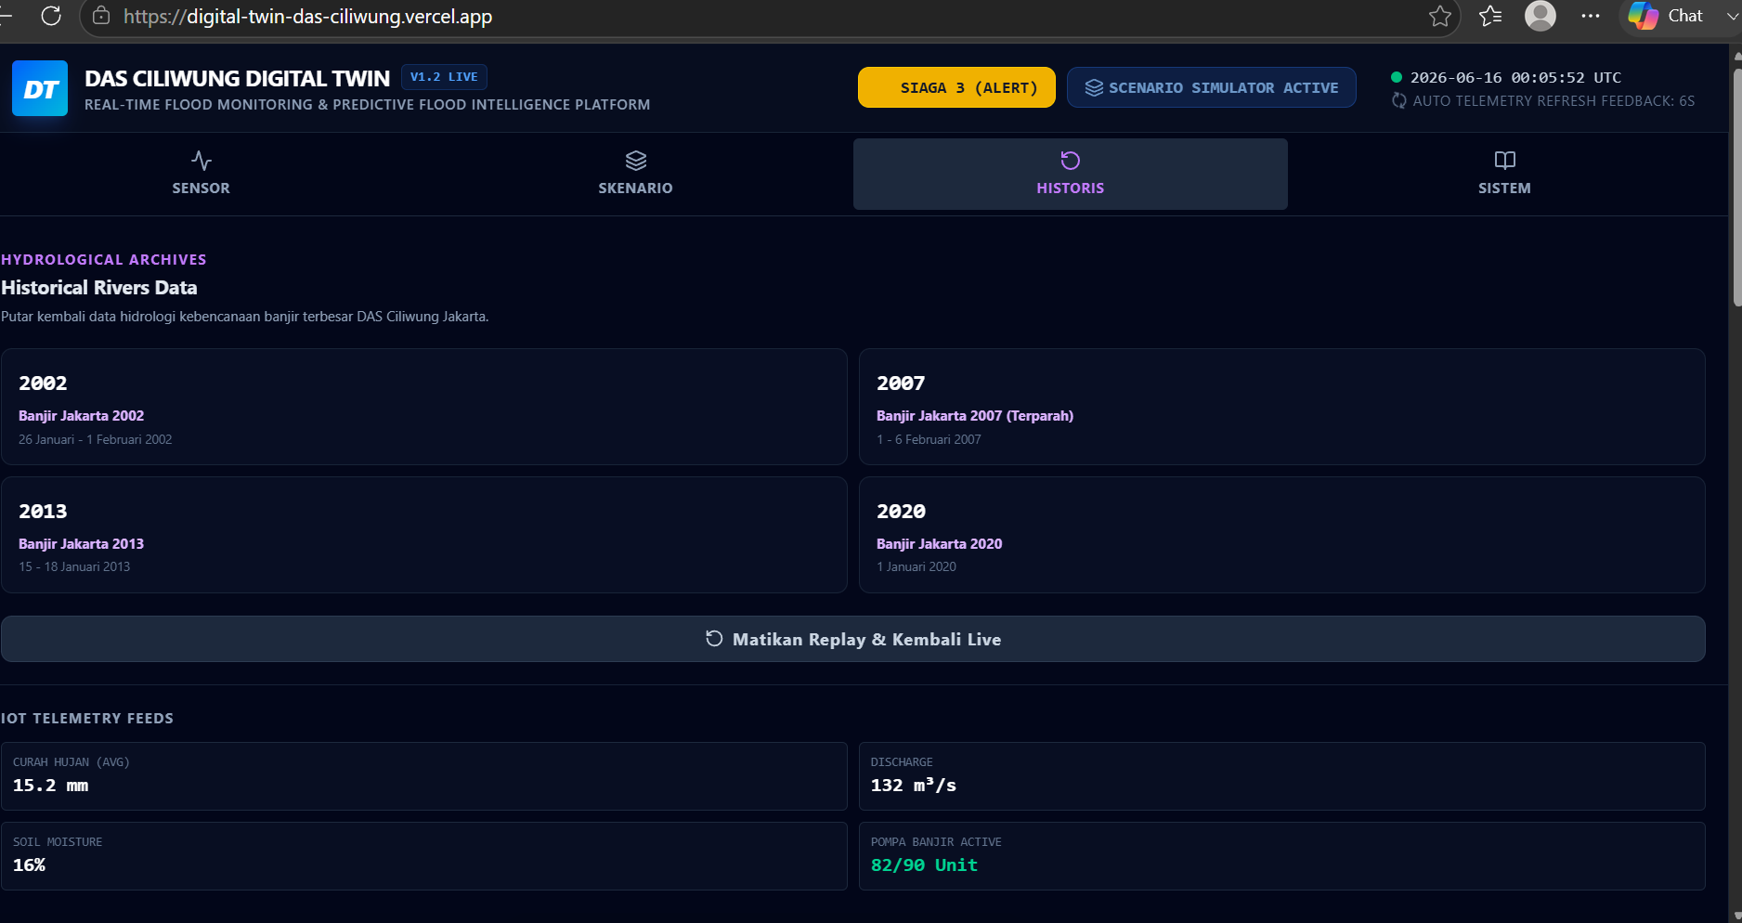

This predictive visualization helps enhance disaster preparedness and supports proactive flood management.

UI/UX Analysis
The UI/UX evaluation was conducted based on Nielsen's fundamental usability principles.
This dashboard demonstrates several strengths:
Learnability
Users can quickly understand the interface thanks to its simple navigation structure.
Efficiency
Key information is accessible from a single screen without requiring multiple interactions.
Memorability
The consistent use of icons, colors, and layout patterns fosters user familiarity.
Error Prevention
Visual alerts help users immediately recognize critical situations.
Satisfaction
The modern dashboard design creates a positive user experience and enhances engagement.

Pembahasan
This implementation demonstrates the practical application of Digital Twin technology in watershed management.
Dibandingkan dengan sistem pemantauan konvensional, dasbor yang diusulkan menawarkan:

• Integrated information visualization
• Real-time environmental condition monitoring
• Flood prediction based on historical data
• Interactive geospatial analysis
The combination of the Digital Twin concept and dashboard visualization provides a comprehensive approach to environmental monitoring and disaster management.

Future developments may include:
• Integration of IoT sensors
• AI-based predictive models
• Mobile applications
• Automated early warning systems

CONCLUSION
This study successfully designed and developed a Digital Twin dashboard for the Ciliwung River Basin, integrating real-time flood monitoring features with flood predictions based on historical data.

The dashboard provides an effective platform for visualizing environmental information through interactive maps, monitoring panels, and predictive analytics. Implementing the Digital Twin concept enables a continuous representation of the river basin's conditions and supports data-driven decision-making.

The research findings indicate that the proposed system has the potential to enhance flood preparedness, environmental awareness, and disaster mitigation efforts. Future research should focus on integrating real-time IoT data and machine learning models to improve prediction accuracy and operational effectiveness.

CRediT Authorship Contribution Statement
Akmal Haikal Hamzah: Conceptualization, Methodology, Software Development, Visualization, Data Analysis, Writing – Original Draft, Writing – Review & Editing.

CONFLICT OF INTEREST STATEMENT
The authors declare no conflicts of interest regarding the publication of this journal.

THANK-YOU NOTE
The author extends their gratitude to UIN Sultan Maulana Hasanudin Banten and the National Research and Innovation Agency (BRIN) for the academic support provided during the completion of this research. Appreciation is also expressed to all parties who contributed to the development and evaluation of the Ciliwung Watershed Digital Twin dashboard prototype.

References
Basic format for books:
- M. Grieves and J. Vickers, "Digital Twin: Mitigating Unpredictable, Undesirable Emergent Behavior in Complex Systems," Springer, 2017.
- F. Tao, H. Zhang, A. Liu, and A. Nee, "Digital Twin in Industry," IEEE Access, vol. 7, pp. 108952–108971, 2019.
- F. Tao, H. Zhang, A. Liu, and A. Nee, "Digital Twin in Industry," IEEE Access, vol. 7, pp. 108952–108971, 2019.
- B. Fuller et al., "Digital Twin: Enabling Technologies and Open Research," IEEE Access, vol. 8, pp. 108952–108971, 2020.

Basic format for periodicals:
- A. Fuller, Z. Fan, C. Day, and C. Barlow, "Digital Twin: Challenges and Future Directions," Journal of Manufacturing Systems, vol. 58, pp. 130–144, 2021.
- J. Nielsen, Usability Engineering. San Francisco, CA: Morgan Kaufmann, 1994.
- D. Norman, The Design of Everyday Things. New York: Basic Books, 2013.
- A. Cooper, About Face: The Essentials of Interaction Design, 4th ed. Indianapolis: Wiley, 2014.

Basic format for reports:
- I. Sommerville, Software Engineering, 10th ed. Boston: Pearson, 2016.
- R. S. Pressman and B. Maxim, Software Engineering: A Practitioner's Approach, 8th ed. New York: McGraw-Hill, 2019.
- BMKG, "Data Curah Hujan Indonesia," Jakarta, Indonesia, 2024.

Basic format for handbooks:
- BNPB, "Data Informasi Bencana Indonesia," Jakarta, Indonesia, 2024.
Examples:
- ESRI, GIS Best Practices for Water Resources Management. Redlands, CA, USA, 2023.
- P. Goodchild, "GIS Applications in Environmental Monitoring," Int. J. Geographical Information Science, vol. 33, no. 4, pp. 745–760, 2020.

Basic format for books (when available online):
- P. Goodchild, "GIS Applications in Environmental Monitoring," Int. J. Geographical Information Science, vol. 33, no. 4, pp. 745–760, 2020.
- World Bank, "Urban Flood Risk Management in Southeast Asia," Washington DC, USA, 2023.
- United Nations, "Global Assessment Report on Disaster Risk Reduction," Geneva, Switzerland, 2024.
- OpenStreetMap Foundation, "OpenStreetMap Documentation," 2024.

Basic format for papers presented at conferences (when available online):
- LeafletJS Documentation, "Interactive Maps for Web Applications," 2024.
- React Documentation, "Building User Interfaces," Meta Open Source, 2024.

